ASSIGNMENT – 5

Q.1 Write a query that will give you all orders for more than Rs. 1000.
Ans. Select * from ORDERS where Amt>1000;
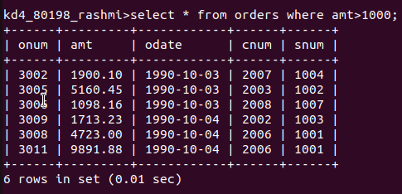

Q.2 Write a query that will give you the names and cities of all salespeople in London with a commision above .10.
Ans. Select Sname, City from SALESPEOPLE where City=’London’ and Comm>.10;

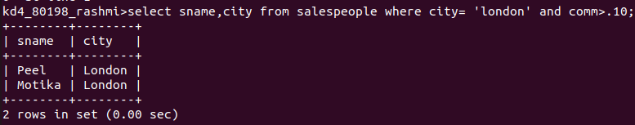

Q.3 Write a query on the Customers table whose output will exclude all customers with a Rating <= 100, unless they are located in Rome.
Ans. Select * from CUSTOMERS where Rating >= 100 or City=’Rome’;

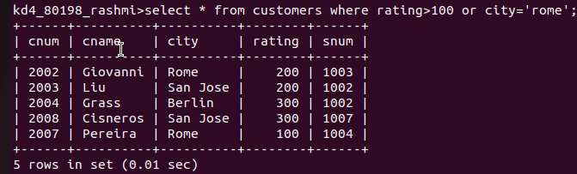

Q.4 What will be the output from the following query?
Select * from ORDER where (amt < 1000 OR
NOT (Odate = ‘1990-10-03’ and Cnum > 2003));
Ans.
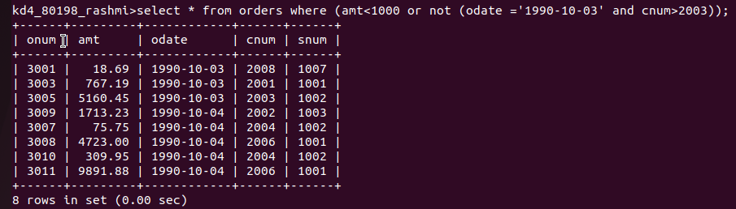

Q.5 What will be the output from the following query?
Select * from ORDERS
where NOT ( (Odate = ‘1990-10-03’ OR Snum > 1006) AND Amt >= 1500);
Ans.
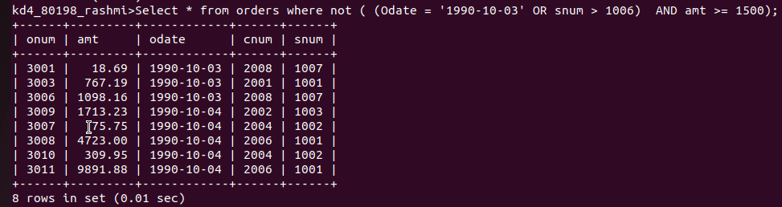

Q.6 What is the simpler way to write this query?
Select snum, sname, city, comm from Salespeople where (comm > .12 or comm < .14);

Ans. Select snum,sname,city,comm from salespeople where (comm> .12 or comm <.14);

